2018-2019 RCIA Programs
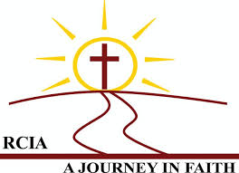
Are YOU interested in learning more about the Catholic Faith?

Is God calling you
to be part of the
Catholic Family?

OR, have you been baptized into the Catholic Church but have not received Confirmation and First Communion, and would now like to complete your initiation?
If you’ve answered “YES” to any of these questions, please consider joining the
Rite of Christian Initiation for Adults (RCIA in English, Cantonese & Mandarin) at St. Therese Chinese Catholic Church!
Classes will start on
October, 14th!
Interested candidates: please fill out this flyer and return it to an usher or contact the parish office at 312-842-6777.

Name:__________________________
Phone:______________________
Email: ______________________

2018-2019 广东话和國語成人慕道班

您想多了解天主教信仰嗎？

天主此刻正邀請您成為
祂大家庭中的一員？

或是, 您曾經在天主教領洗,卻
未領受堅振和初領聖體, 而您現
在想要完成天主教的入门圣事？

如果對以上任何一個問題，您的答复是肯定的，請考慮加入

中國城聖德力天主教堂
广东话和國語成人慕道班
課程將於十月14号開始

有兴趣的朋友,請填寫此傳單並交給教堂接待人員,或是和教堂連絡 312-842-6777.

广东话慕道班

姓 名 :_______________________
電話 :________________________
電郵:_____________________
國語慕道班

姓 名 :_______________________
電話 :_________________________
電郵:______________________

