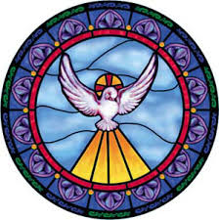

Please pray for the following students as they prepare for their Confirmation on Sunday, April 28, 2019:

|  |  |
| --- | --- |
| Javier Banks | *Alma Gyabin* |
| Ephraim Balagun | *Lucy Harley* |
| Joel Casey | *Ivan Hokens* |
| Madison Chan | *Nathan Lau* |
| Elizabeth Chee | *Caitlyn Lee* |
| Chloe Culen | *Wendy Martinez* |
| Ryan Daly | *Alexander Moy* |
| Jacquelline Del Raso | *Mathew Schiml* |
| *Bruce Garner* | *Amelia Maya Wong* |
| *Xahil Gonzalez* | *Samantha Woo* |