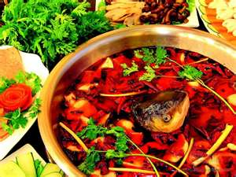**St. Mother Teresa of Calcutta Parish**

**St. Therese Worship-site**

**New Year’s Eve**

**Mass and Hot Pot Dinner**

**Please join us for a Mass of Thanksgiving on**

**Tuesday, December 31stat 5:00p.m. Followed by**

**Benediction and our Annual Hot Pot Dinner**

**in the community room.**

**All are welcome!**

**It will be a fun evening of fellowship to ring in the New Year!**

**Adults: $10.00**

**Free for Children 5 and under**

**REGISTRATION IS REQUIRED by Friday Dec. 27!**

**Please sign up at the church entrance table or call our parish office so we can plan for adequate food.**

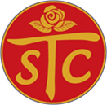**Thank YOU!**